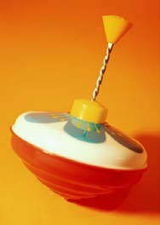Engineering in Reverse! Activity – Engineering in Reverse Worksheet

In the box below, complete a *detailed* drawing of the internal components (i.e, the inside mechanisms) in the push-toy before it has been disassembled.

Your drawing should include:

* Label for all parts
* Brief description of each part’s function(s)

**BEFORE Disassembly**

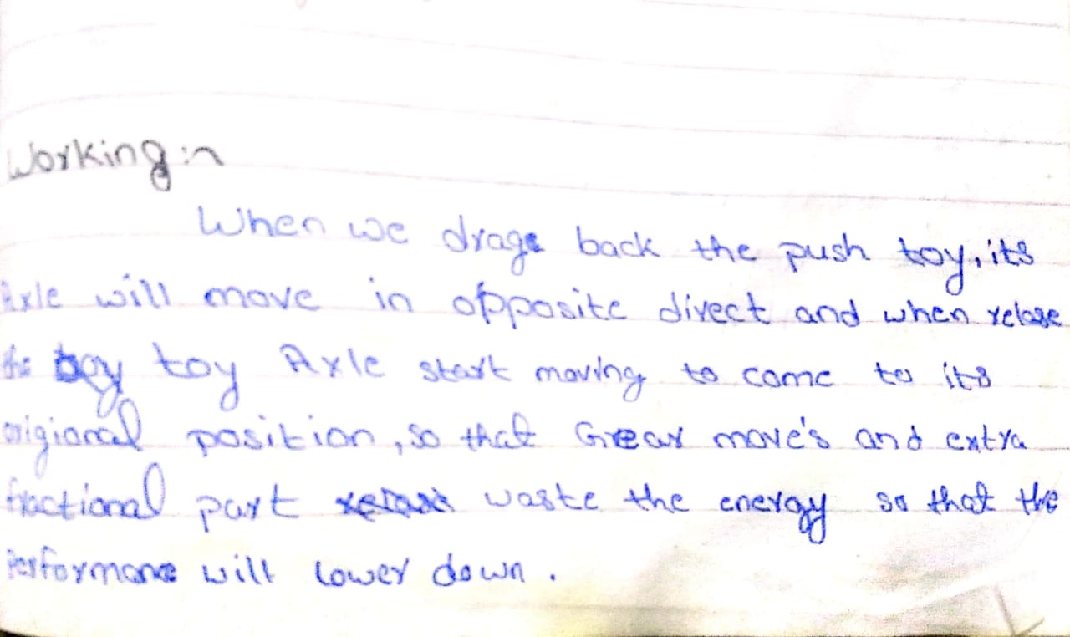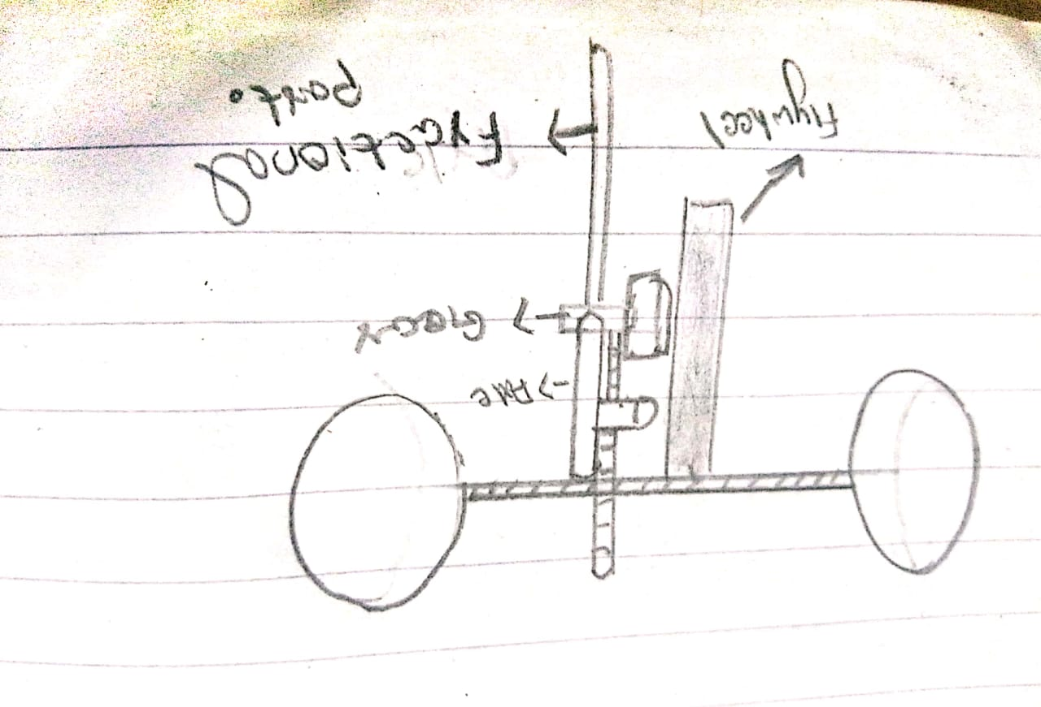

In the box below, complete a *detailed* drawing of the internal components of the push-toy after it has been disassembled. Your drawing should include:

* Label for all parts
* Brief description of each part’s function(s)

**AFTER Disassembly**

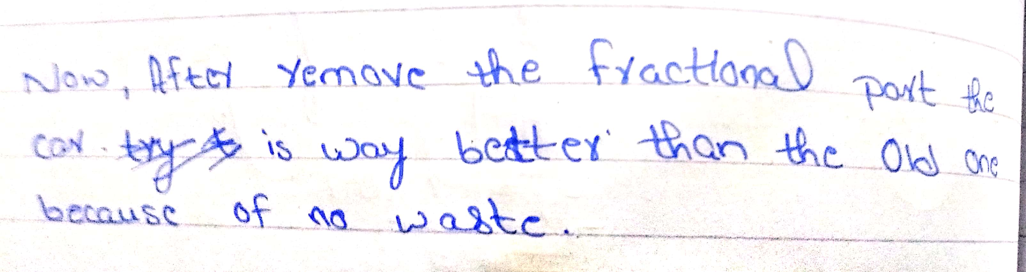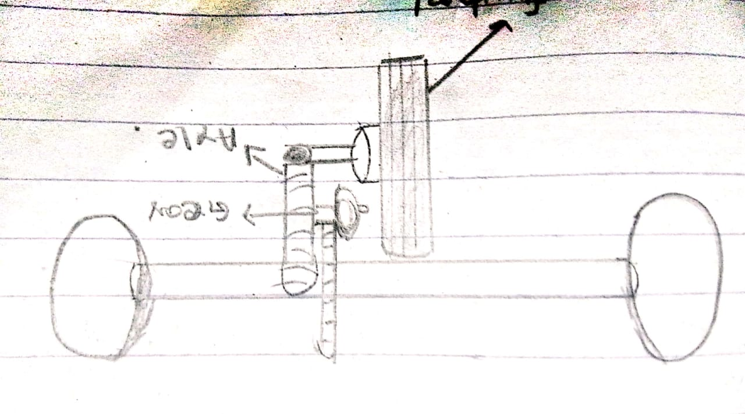

After you have completed your drawing, answer the following questions.

1. What does this device do? What parts make it work this way?

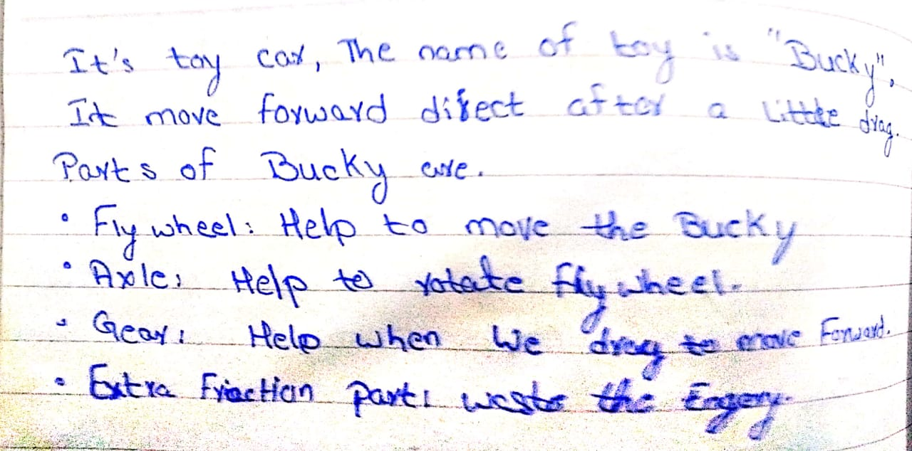

1. How would you improve the way this device is made?

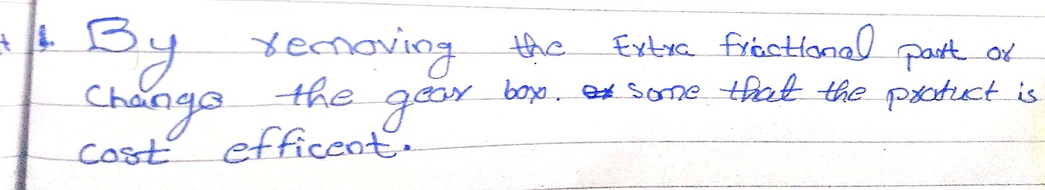

1. How could you change this device to make it more cost effective to produce?

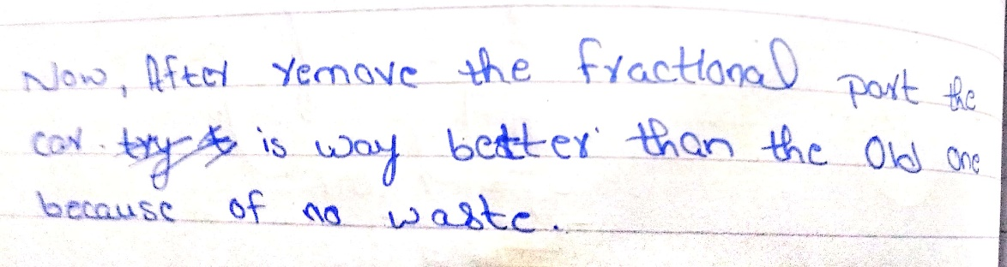

1. Can you redesign this device to make it function differently? How would you do this?

